Build a personal web site to use as an online CV but more comprehensive than a standard CV.

1. **Design Guidelines**
   1. **Mental models**
      1. The target users for my website will web developer job recruiters who are trying to find candidates to fill roles for their client. I chose to search for recruiters on LinkedIn to determine the correct mental model to use. I picked Lorraine McGrath a job recruiter with 6 years’ experience working for realTime Ltd, an IT recruitment company based in both Dublin and Belfast. They provide IT staffing for both Permanent and Contract roles across Ireland. They specialise in sourcing niche technologies and skills, while offering market insights and expert advice. I will use Lorraine as a representation of the main user to my website.
      2. Lorraine is very active on LinkedIn with her profile fully fleshed out. Her posts consist of templated adverts for current positions she has on offer. She posts videos where she talks about what she is looking for in a candidate. She is very to the point and technical in her posts leaving out business speak. Other posts are very upbeat and include blog articles and history posts on tech. Her mental model when searching for someone would most likely have a similar profile and post pattern.
      3. Lorraine’s process is to post a job advert on her LinkedIn feed with job roles available, she then reviews a candidate’s CV if they applied for the role. Lorraine calls the candidate to confirm their CV matches the person and get a feel for them on the phone. Lorraine then goes back to her client to pitch them on the candidate and arrange an interview. She would expect to see a LinkedIn profile and that the candidate can give her a word version of their CV.
   2. **Metaphors**
      1. I will model my personal website off LinkedIn’s profile page which will be familiar to Lorraine.
      2. A call to action button will allow Lorraine to download my CV in word format so she can edit it into her company’s template, she would use to pitch me to her clients.
      3. I will make the main image on the page my profile picture and so she can get a look at me before she reads my CV. I will also include a video of myself near the end so Lorraine can get an idea of who she will be talking to before she calls me, this is to speed up her phone interview process.
      4. Lorraine is short and to the point so the website will need to reflect this. Main information and contact details will be at the top. As Lorraine scrolls down more of my information will become available to her. I will keep my profile picture, name and call to action button as a sticky navigation bar so at any point Lorraine can action my CV and contact me.
      5. I will also use main technical words from Lorraine’s posted job descriptions so if Lorraine is in a hurry or lots of other candidates, she can do a search for keywords and jump to the relevant information.
   3. **Gestalt Laws**
      1. **Proximity**
         1. Social media icons will be grouped together under my profile picture. Call to action button will also be under my profile picture
         2. Main contact information will be at the top.
         3. Information on work experience, education and hobbies will all be grouped into their own individual sections.
      2. **Similarity**
         1. For each work experience element, the website will follow the same format. Date range, Role, Company, Address, tasks and responsibilities
         2. The website will consist of 3 main elements that follow the golden ratio, A feed on the right a profile picture with call to action button on the left and a navigation bar at the top.
      3. **Closure**
         1. The website will use outline icons within a coloured shape to give the illusion of closure. Images will be spaced apart to allow someone to group them and close the gaps.
      4. **Continuity**
         1. The left profile picture and call to action button will be sticky to follow the feed as the user scrolls this is to associate me with the content and if something in the feed (e.g. work experience or education) sparks the user to want to contact me the call to action will be on the left for them.
      5. **Figure-Ground**
         1. Colour pallet will be kept simple with different shades to give depth
         2. The foreground will be darker than the background to make it stand out. I will make use of box shadowing to focus attention towards the call to action button close to the centre of the webpage
      6. **Symmetry**
         1. In work experience and education, a timeline will be drawn horizontally with each employer or school listed by date
   4. **Nielsen’s Heuristics**
      1. The user will see a loading bar fill up as they scroll through the website to get visibility of how far they have scrolled and how much is left to see.
      2. The website will resemble a typical paper CV and LinkedIn as both are familiar to what the user sees in the real world every day.
      3. A jump to top button will be available to allow the user control and freedom to go back to the start
      4. For consistency and standards, the website will be broken into sections such as about me, contact form, work experience, education and hobbies & achievements. I will also use words from job descriptions posted by recruiters.
      5. To help with error prevention I will do form validation in the contact form section. When they click submit, I will show them the message they are about to send. If they are happy, they can click the confirmation button otherwise they can close the message and try again.
      6. To use recognition rather than recall I will put my name and current job title under my profile picture so as the user scrolls, they will be able to know what I am currently working as
      7. For flexibility and efficiency of use I will put a jump to top button for the user to return to the start quickly.
      8. To keep with an aesthetic and minimalist design I will use less colours.
      9. If a user tries to use the contact form and an error or issue occurs I will display it near the field the issue arose along with a top message to help guide the user towards the error. With form validation I will help them recognise, diagnose and recover from any errors before they send a message to me.
      10. I will keep the site simple and labelled to make it easy to search and be focused on the user’s tasks.
2. Wireframe of homepage (smartphone, tablet and desktop)

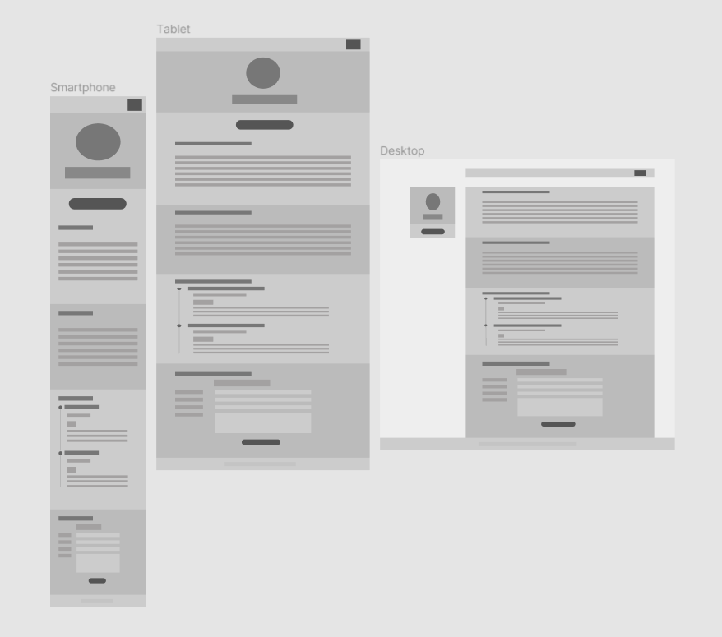

*Full wireframes in separate file*

Prototype – Medium Fidelity of website

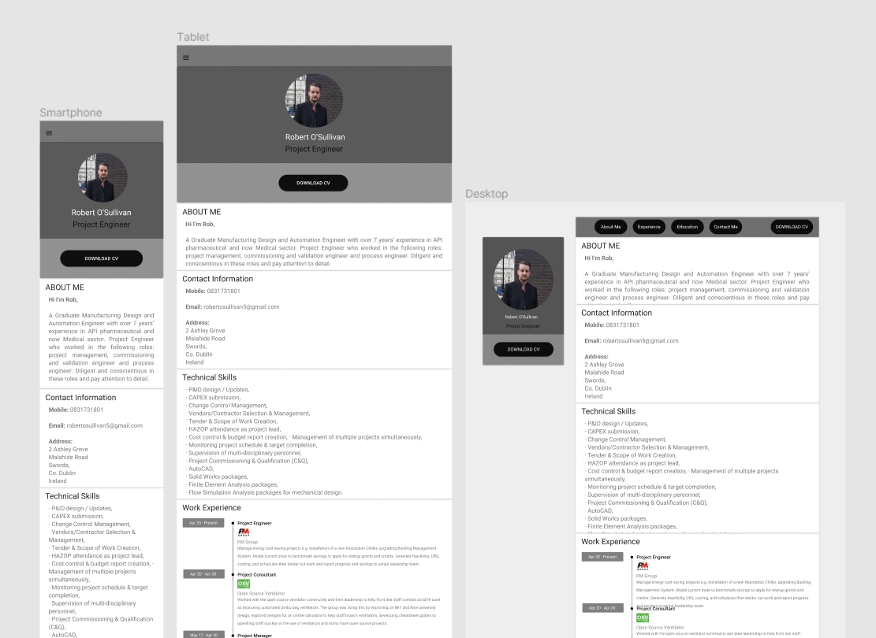

*Full prototype in separate file*